Department of Computer Science and Engineering (Data Science)
CSDS-A | Batch A4 (CSE - Data Science, Section A)
Advanced Optimization in E-Commerce Logistics: Combining Matheuristics With Random Forests for Hub Location Efficiency
(HubOptima)
S.No. | Student name | Roll / hall ticket no.
1 | CH.ARCHANA | 23K91A6745
2 | A.MEENAKSHI | 23K91A6705
3 | B.ARUN | 23K91A6734
4 | A.SAMPATH | 23K91A6712
Under the guidance of: [GUIDE NAME], [DESIGNATION]
DESIGN AND IMPLEMENTATION
This document describes the design of HubOptima and how it was implemented: the architecture, the modules, the data model, the API, key code walkthroughs, and the reasoning behind the main implementation decisions.

1 System Architecture
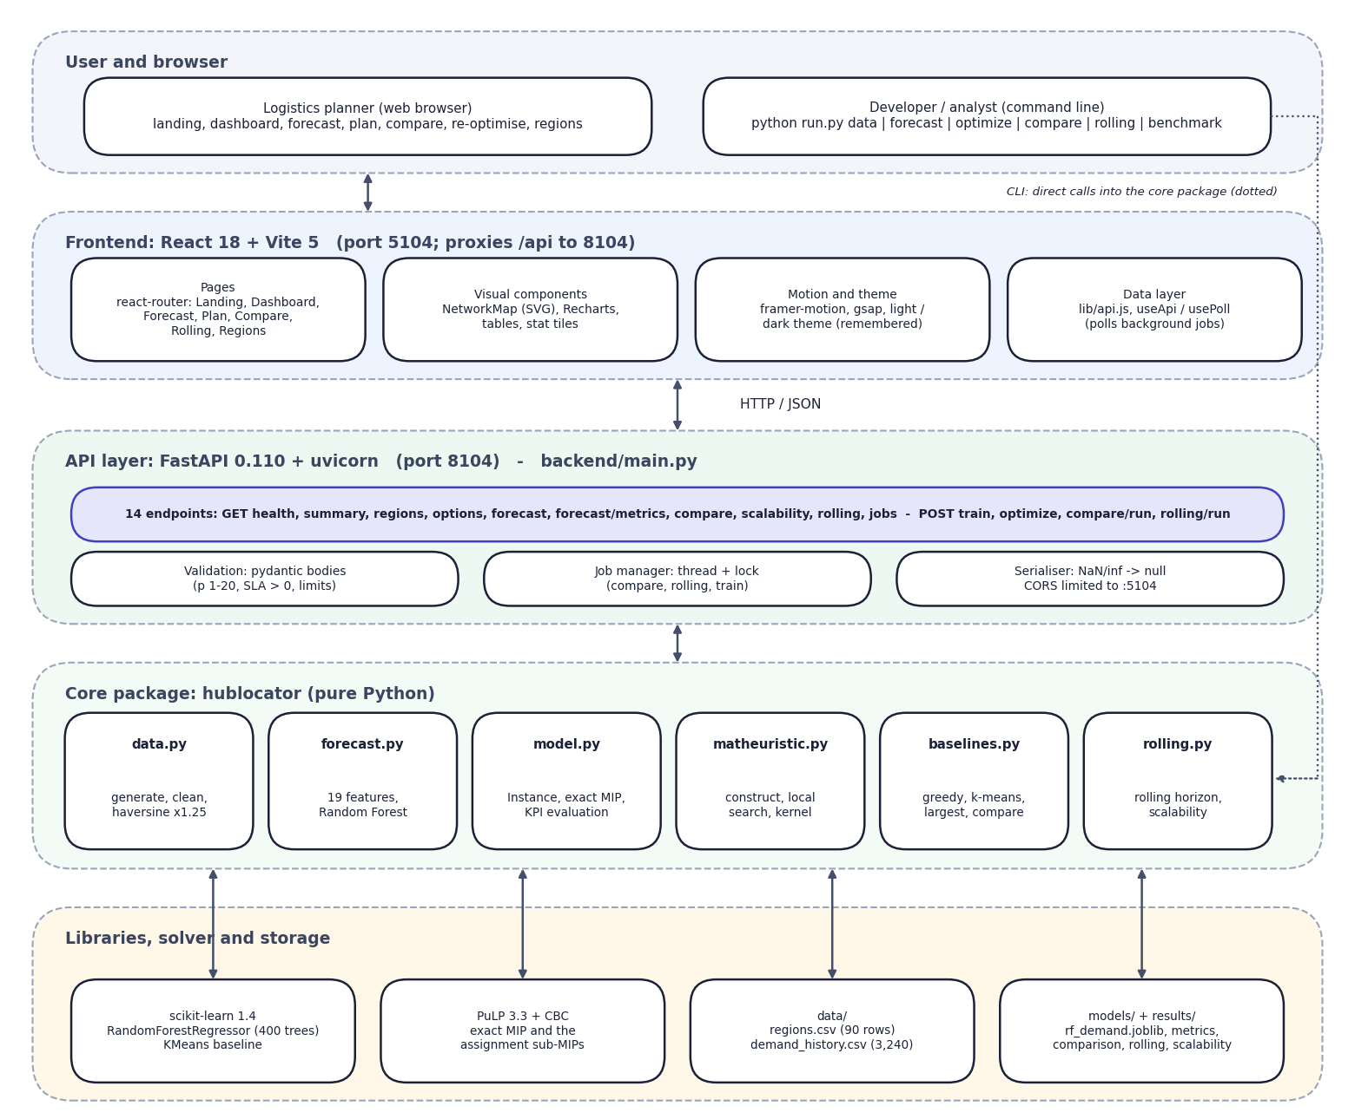
Fig. 1: System architecture of HubOptima
The architecture has five layers. The user works in a browser, or a developer uses the command line. The frontend is a React application served by Vite on port 5104; it holds the seven pages, the SVG network map, the charts, the theme and the small data layer (api.js, useApi, usePoll) that polls background jobs.
The API layer is a FastAPI service on port 8104 with 14 endpoints. It validates request bodies with pydantic, runs long jobs in a thread guarded by a lock, and converts numpy values to JSON (NaN and infinity become null). The core package hublocator contains all of the science: data preparation, the Random Forest, the hub model and exact solver, the matheuristic, the baselines and the rolling-horizon simulation. No forecasting or optimisation logic lives in the API layer.
The bottom layer holds the libraries (scikit-learn, PuLP with CBC) and the files that act as storage: two CSV files in data/, the trained model and metrics in models/ and the result files in results/. The command line calls the core package directly, which is why the dotted line bypasses the web tiers.
Design principles. (1) One implementation of the science: the command line, the classic Flask interface and the FastAPI service import the same package. (2) Files as storage: the artefacts a planner would want to inspect or replace (the CSV inputs, the model, the JSON results) stay readable files. (3) Thin API: it validates, runs jobs and serialises; it never decides anything about hubs. (4) Honest evaluation: the evaluation function takes the realised demand separately from the planning demand, so capacity overload is visible.

2 Module Breakdown
Table 1: Modules, sizes and responsibilities
Module | Lines | Responsibility | Main functions
config.py | 31 | Paths, random state, default model parameters | DEFAULTS, RANDOM_STATE
data.py | 177 | Dataset generation, loading, preprocessing, distances, summary | generate_dataset, load_dataset, distance_matrix, dataset_summary, haversine_km
forecast.py | 145 | Features, Random Forest training and evaluation, forecasting | build_features, train_forecaster, forecast_next_period, forecast_for_period
model.py | 203 | Instance, exact MIP, assignment sub-MIP, greedy assignment, KPI evaluation | Instance, solve_exact, assign_exact, assign_greedy, evaluate_solution
matheuristic.py | 167 | Construction, MIP-priced local search, kernel search | construct, solve_matheuristic, _bound, _price
baselines.py | 121 | Traditional methods and the comparison runner | solve_greedy, solve_kmeans, solve_largest_markets, run_comparison
rolling.py | 140 | Rolling-horizon simulation and the scalability benchmark | rolling_reoptimisation, inflate_network, scalability_benchmark
webapp.py | 349 | Original Flask interface and JSON API (port 5000) | create_app and five routes
backend/main.py | 272 | FastAPI layer for the React application (port 8104) | 14 endpoints, start_job, clean
run.py / tests.py | 135 / 72 | Command-line entry point and smoke tests | cmd_data ... cmd_serve; test_data ... test_webapp
frontend/src | 4,235 | React application: 7 pages, UI kit, charts, SVG map, theme | pages/*.jsx, components/ui, lib/api.js, useApi.js

3 Data Model and Storage Design
The system keeps its data in files. This was a deliberate choice: the order history of a regional network (3,240 rows here) is small, the artefacts are easier to inspect and replace as files, and no server process or credentials are needed. The consequence is that there are no transactions and no multi-user access; background jobs overwrite result files.
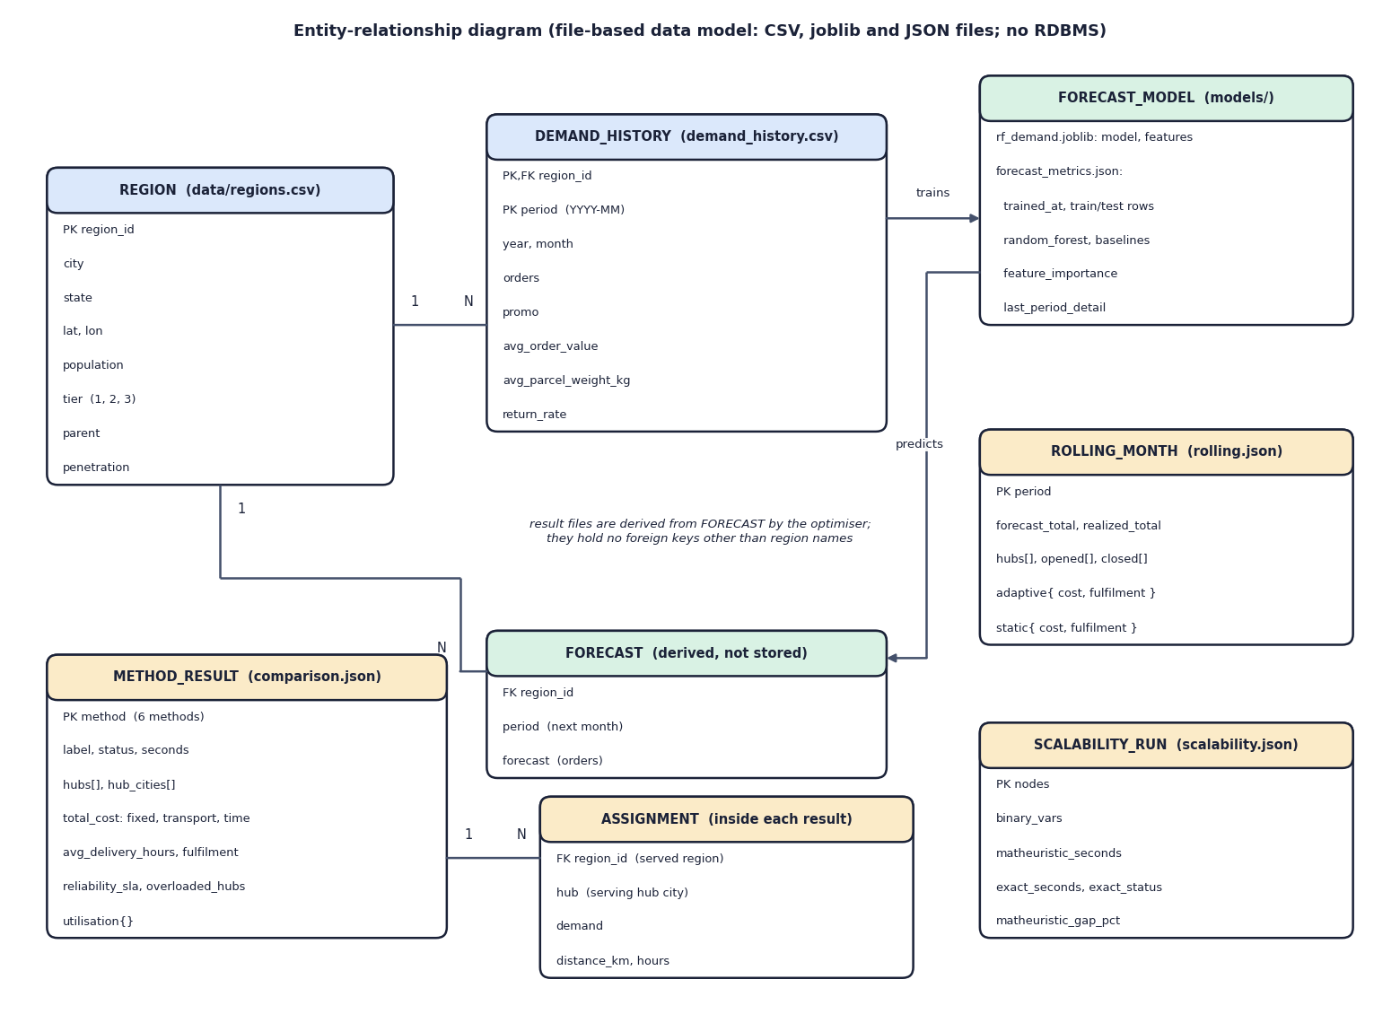
Fig. 2: Entity-relationship diagram of the file-based data model
HubOptima does not use a database. Its data are two CSV files, a joblib model with a JSON metrics file, and JSON result files. The diagram shows them as entities so that the relationships are explicit. A region has many monthly demand-history rows (primary key region and period). The forecast model is trained from the demand history and predicts a forecast per region, which is derived and not stored. The result files (method results with their region-to-hub assignments, rolling-horizon months and scalability runs) are produced by the optimiser from forecasts and hold region names rather than foreign keys.
Table 2: Files that form the data model
File | Fields | Rows / size | Written by
data/regions.csv | region_id, city, state, lat, lon, population (millions), tier (1-3), parent, penetration | 90 rows | python run.py data
data/demand_history.csv | region_id, period (YYYY-MM), year, month, orders, promo, avg_order_value, avg_parcel_weight_kg, return_rate | 3,240 rows (90 x 36) | python run.py data
models/rf_demand.joblib | the fitted RandomForestRegressor and its 19 feature names | 38.5 MB | train_forecaster
models/forecast_metrics.json | trained_at, train/test rows and periods, metrics of three forecasters, feature importance, December 2025 per-region detail | about 12 KB | train_forecaster
results/comparison.json | parameters, forecast and realised totals, and for each of six methods the hubs, costs, KPIs, utilisation and the 90-row allocation | about 118 KB | run_comparison
results/rolling.json | per month: forecast and realised totals, hubs, opened and closed hubs, adaptive and static KPIs; averages | about 6 KB | rolling_reoptimisation
results/scalability.json | per instance size: binary variables, matheuristic and exact time and objective, gap, exact status | about 1 KB | scalability_benchmark

Integrity rules in code. load_dataset drops duplicate (region, period) rows, coerces orders to numbers, sorts by region and period, interpolates gaps inside each region and drops rows that remain empty. tier and penetration receive defaults if absent, and year and month are derived from period if missing. These guards are not exercised by the generated data, which has no gaps, but they make a real file usable.

4 Application Architecture
The web application has three tiers. The React frontend (port 5104) never contains optimisation logic: it sends parameters to the API and draws what comes back. Vite proxies /api to the FastAPI service (port 8104), so the browser sees one origin. The FastAPI service loads the dataset and the model once at start-up and imports the functions of the hublocator package. Long computations (comparison, scalability benchmark, rolling horizon) run as background jobs in a thread, with a lock so that only one job of each kind runs at a time and with its status exposed at /api/jobs; training and planning run inside the request.
The classic interface of the original implementation (Flask, server-rendered, port 5000) is retained and runs the same functions, which keeps the numbers of the two interfaces identical.

5 API Design
Table 3: The 14 API endpoints
Method | Path | Purpose | Notes
GET | /api/health | status, version, solver, model present | used for the status chip and by run.bat
GET | /api/summary | dataset, forecaster, comparison and rolling digest | Dashboard
GET | /api/regions | the 90 regions with average orders | Regions page and the map
GET | /api/options | planning months, defaults, solver availability | fills the planning form
GET | /api/forecast | next-month forecast per region and model metrics | Forecast page
GET | /api/forecast/metrics | full metrics, importances, last-month detail | Forecast page
GET | /api/compare | saved comparison | Compare page
GET | /api/scalability | saved scalability runs | Compare page, Scalability tab
GET | /api/rolling | saved rolling-horizon results | Re-optimise page
GET | /api/jobs | state of background jobs | polled every 2 s while a job runs
POST | /api/train | retrain the forecaster (synchronous) | 409 if already running
POST | /api/optimize | plan hubs for a month | validated body; returns solution, KPIs, demand used
POST | /api/compare/run | start a comparison or scalability job | 409 if a job is running
POST | /api/rolling/run | start a rolling-horizon job (2-12 months) | 409 if a job is running

The request and response below were recorded from the running service (December 2025, four hubs, matheuristic). The response is trimmed for length; the full response also contains the 90-row allocation and the demand vector.
Listing: request body of POST /api/optimize
{
"period": "2025-12",
"n_hubs": 4,
"method": "matheuristic"
}

Listing: response of POST /api/optimize (trimmed)
{
"period": "2025-12",
"realized": true,
"sol": {
"status": "Matheuristic",
"hubs": [
1,
2,
5,
39
],
"objective": 54722309.15060887,
"seconds": 2.34,
"iterations": 1,
"subproblems_solved": 14,
"kernel_status": "Optimal"
},
"kpi": {
"n_hubs": 4,
"hub_cities": [
"Mumbai",
"Delhi",
"Kolkata",
"Bengaluru-N"
],
"total_cost": 50039855.0,
"fixed_cost": 12000000.0,
"transport_cost": 14358230.0,
"time_cost": 23681626.0,
"cost_per_order": 31.406,
"avg_delivery_hours": 9.91,
"max_delivery_hours": 27.07,
"avg_distance_km": 225.3,
"fulfilment_rate": 1.0,
"reliability_sla": 1.0,
"overloaded_hubs": 0,
"utilisation": {
"1": 0.892,
"2": 0.751,
"5": 0.431,
"39": 0.828
}
},
"kpi.assignment[0]": {
"region": "Hyderabad",
"region_id": "R001",
"hub": "Bengaluru-N",
"demand": 90287,
"distance_km": 546.7,
"hours": 18.1
},
"demand_used": "[90 values]"
}

The four original JSON contracts of the Flask interface (/api/forecast, /api/optimize, /api/compare, /api/rolling) keep their response shapes in the FastAPI layer, which the smoke test checks.

6 Key Code Walkthroughs

6.1 Building the optimisation instance
The Instance constructor turns the regions, the demand vector and the parameters into the matrices used by every solver: delivery times, unit costs, tier-scaled fixed costs and the capacity of a hub.
Listing: hublocator/model.py - Instance.__post_init__
def __post_init__(self):
p = {**config.DEFAULTS, **self.params}
self.params = p
n = len(self.regions)
self.n = n
self.time = self.dist / p["truck_speed_kmph"] + p["hub_handling_hours"] # hours
np.fill_diagonal(self.time, p["hub_handling_hours"] * 0.5) # local delivery
self.unit_cost = p["transport_rate"] * self.dist + p["time_penalty"] * self.time
tier_mult = self.regions["tier"].map({1: 1.35, 2: 1.0, 3: 0.75}).fillna(1.0).to_numpy()
self.fixed_cost = p["fixed_cost_per_hub"] * tier_mult
total = float(self.demand.sum())
self.capacity = np.full(n, p["capacity_factor"] * total / p["n_hubs"])
self.p = int(p["n_hubs"])

6.2 Screening and pricing moves in the matheuristic
Every candidate move is first scored with the cheap greedy estimate; moves are sorted by it, the loop stops as soon as the estimate is more than 6% above the current objective, and the remaining moves are priced by the exact assignment MIP. The first strictly better plan is accepted and the search restarts.
Listing: hublocator/matheuristic.py - screen and price
scored = []
for kind, h, j in moves:
trial = [x for x in hubs if x != h] + ([j] if j is not None else [])
scored.append((_bound(inst, trial), kind, h, j, trial))
scored.sort(key=lambda t: t[0])
for b, kind, h, j, trial in scored:
if time.time() - t0 > time_limit * 0.7:
break
if b > obj * (1 + screen_tol):
break # greedy bound too poor to be worth a MIP
a, o = _price(inst, trial, cache, sub_time_limit)
if o < obj - 1e-6:
hubs, assign, obj, improved = trial, a, o, True
log.append({"phase": f"local-search {kind}", "hubs": sorted(hubs), "objective": o,
"t": round(time.time() - t0, 2)})
if verbose:
print(f" {kind:<5} -> {o:,.0f} hubs={[inst.regions.city[x] for x in hubs]}")
break # first improvement

6.3 Scoring a plan on realised demand
evaluate_solution is where forecast error becomes visible: capacity stays at the planned level while the load follows the realised demand, so an overloaded hub serves only the share that fits.
Listing: hublocator/model.py - evaluate_solution (core)
load = np.zeros(inst.n)
np.add.at(load, assign, d)
served = np.minimum(load, inst.capacity) # orders each hub can process
fulfil_by_hub = np.where(load > 0, served / np.maximum(load, 1e-9), 1.0)
fulfilment = float((fulfil_by_hub[assign] * d).sum() / total)

on_time = (t <= inst.params["sla_hours"]).astype(float)
reliability = float((on_time * fulfil_by_hub[assign] * d).sum() / total)

7 Implementation Decisions and Reasoning
Table 4: Implementation decisions
Decision | Reason | Consequence
Single allocation | Matches the classic p-hub median family [8] and keeps the assignment sub-problem small | No split flows; a distant region may be served by one far hub
Capacity = factor x planned demand / p | Ties capacity to the forecast so that forecast error shows as overload | Under-forecast leads to overloaded hubs; fulfilment below 100%
Soft SLA by default, hard SLA optional | A hard SLA can make a plan infeasible (the edge-case test uses 1 hub and a 5 h SLA); a soft SLA still penalises late delivery | Reliability is reported, not guaranteed
Price hub sets with an exact assignment MIP | Makes every accepted plan optimal for its hub set | About 14-18 sub-MIPs per search
Screen moves with a greedy estimate (6%) | Avoids pricing the large majority of moves | A good move whose estimate is poor can be missed
First-improvement with restart | Simple, and re-ranks candidates after each change | Search is not guaranteed to reach the global optimum
Kernel search of 24 candidates | Gives the exact solver a small enough model to finish | Result can be slightly worse than the full MIP (3.67% at 270 nodes)
Time-based split and no look-ahead | Mirrors real use: the future is not known | Only six test months
Model trained once; lags updated each month | Keeps re-optimisation fast (training takes under a second, so retraining is possible but was not done monthly) | The rolling horizon tests re-forecasting and re-planning, not re-training
Files instead of a database | Small data; artefacts easy to inspect and replace | No transactions or multi-user access
Thin API, shared package | One implementation for CLI, Flask and FastAPI | The numbers of all interfaces agree
Background jobs in threads | Comparison and rolling runs take 20 s to a few minutes | Single process; jobs are lost if the server stops

A caution about in-sample months. The Random Forest is trained on rows up to June 2025. For planning months before July 2025 the 'forecast' is therefore partly in-sample. All results reported in this document use the six test months (July to December 2025), for which the model saw no data.

8 Security and Error Handling

8.1 Error handling
Table 5: Error handling
Situation | Behaviour | Checked by
Body out of range (for example n_hubs = 0) | HTTP 422 with the field and the reason (pydantic) | smoke test
Unknown planning month | HTTP 400 with 'Unknown planning month 1999-01.' | smoke test
A job of the same kind is already running | HTTP 409 with an explanation | code review
Infeasible plan (for example a hard SLA that cannot be met) | 200 with an error field: 'No feasible solution (try more hubs, a larger capacity factor or a soft SLA)' | smoke test (hard-SLA edge case)
Exception inside a solver or a job | Caught; the message is returned (planning) or stored in the job status (jobs) | code review
NaN or infinity in a result | Converted to null so that the JSON is valid | code review
API not reachable from the browser | The page says the backend on port 8104 could not be reached | browser walkthrough

The validation message recorded for n_hubs = 0 is: 'Input should be greater than or equal to 1' on field n_hubs.

8.2 Security
- CORS is limited to http://localhost:5104 and http://127.0.0.1:5104.
- No secrets are stored: the .env file contains only the two port numbers.
- Request bodies are validated with types and ranges, which bounds the work a request can ask for (for example time limit 2-300 s, p 1-20).
- There is no authentication, authorisation or rate limiting. Anyone who can reach port 8104 can retrain the model or start jobs that overwrite the result files. The application is therefore meant for a trusted local machine; this is recorded as a limitation, and no penetration test was carried out.

9 User Interface Design
The web application is a single-page React application with a persistent sidebar (Dashboard, Forecast, Plan hubs, Compare methods, Re-optimise, Regions), a top bar showing the API and solver status, and a light and a dark theme. The theme follows the operating-system setting until the user chooses and is then remembered in the browser. The visual style, called 'Soft Pastel Calm' in the project documents, uses soft colours, rounded cards and short animations; animations respect the reduced-motion setting of the operating system (the SVG map uses useReducedMotion).
Table 6: Pages of the web application
Route | Page | What the user can do
/ | Landing | Read the pipeline in five steps and the headline results; open the app
/app | Dashboard | See the dataset size, forecaster accuracy and the monthly volume chart
/app/forecast | Forecast | Compare the Random Forest with the naive forecasters, see feature importance, search the next-month forecast per region, view the December back-test, retrain
/app/plan | Plan hubs | Set the month and parameters, choose matheuristic or exact, run, and read KPIs, the network map, utilisation, cost split, search log and allocation table
/app/compare | Compare methods | Run the six-method comparison for a month or the scalability benchmark in the background; see tables and charts
/app/rolling | Re-optimise | Run the rolling horizon for 2-12 months; see fulfilment and cost by month and the hub changes
/app/regions | Regions | Search and filter the 90 regions; see where demand sits on a map

9.1 Interaction details
- Validation before sending. The planning form checks every numeric field against the same ranges as the API (for example p between 1 and 20) and shows the message under the field.
- Progress and errors. While a plan is computed the page shows the four pipeline steps (forecast demand, build the model, solve, score) and the elapsed time; an infeasible plan produces an explanation rather than an empty page; a network error says that the API on port 8104 could not be reached.
- Background jobs. Comparison, scalability and rolling runs return immediately and the page polls /api/jobs every two seconds until the job finishes.
- Shared state. The Plan page keeps the last plan and form while the user visits other pages.
- Internet. The only external request is the Google Fonts stylesheet declared in index.html; without a connection the browser falls back to system fonts and the application works unchanged.

10 Installation and Execution
Requirements. Python 3.10 or later and Node.js 18 or later. On Windows, double-click run.bat in 8.ProjectCode; it reads the ports from .env, installs missing Python and npm packages, starts the API and waits for /api/health, starts the web server and opens http://localhost:5104.
Listing: installation and commands
pip install -r backend/requirements.txt
python -m uvicorn backend.main:app --host 127.0.0.1 --port 8104 # terminal 1
cd frontend && npm install && npm run dev # terminal 2 -> http://localhost:5104

python run.py forecast # train the Random Forest (about 1 s)
python run.py optimize --period 2025-10 --hubs 6
python run.py compare --period 2025-10
python run.py rolling --months 6
python run.py benchmark --factors 1 2 3
python tests.py # four smoke tests
python scripts/smoke_test.py # 18 API checks

A trained model and pre-computed results are included, so the application works immediately. Retraining, comparison, benchmark and rolling runs overwrite models/ and results/.

